# Feature distribution and analysis for big_dataset

**RISE_TIME:**

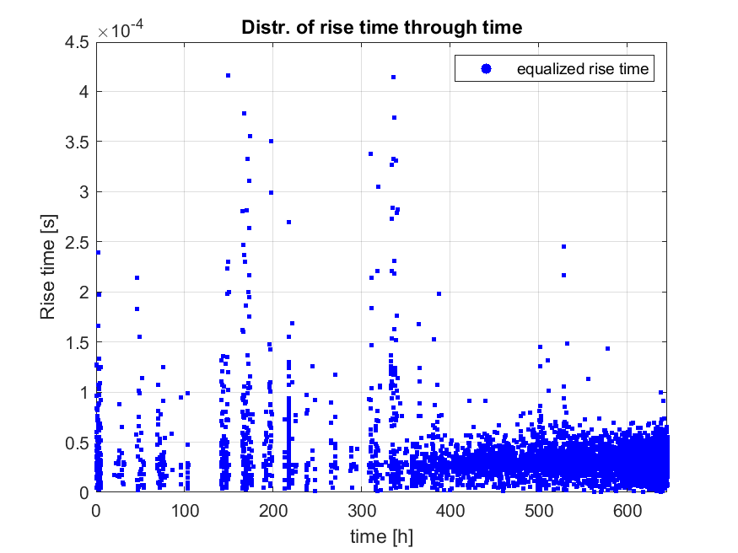

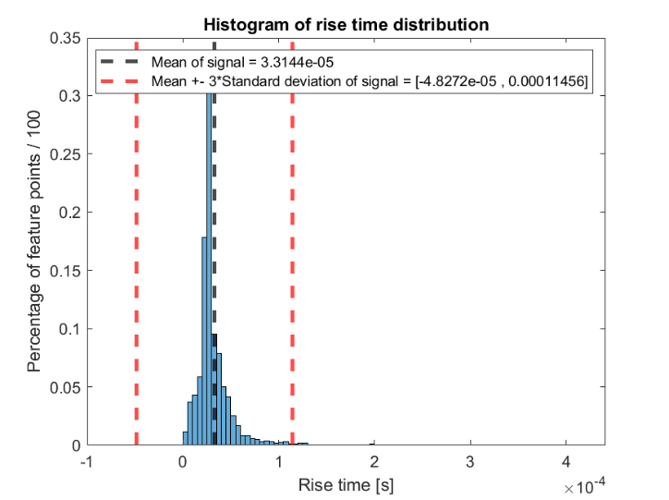

**Potencijalni outlieri iznad 110 us:**

** **